**Lab 28**

**Configuring Relational database service (RDS)**

**Note: You will select only t2.micro instance type in this scenario. Otherwise charges will be applicable.**

Click “Relational Database service”.

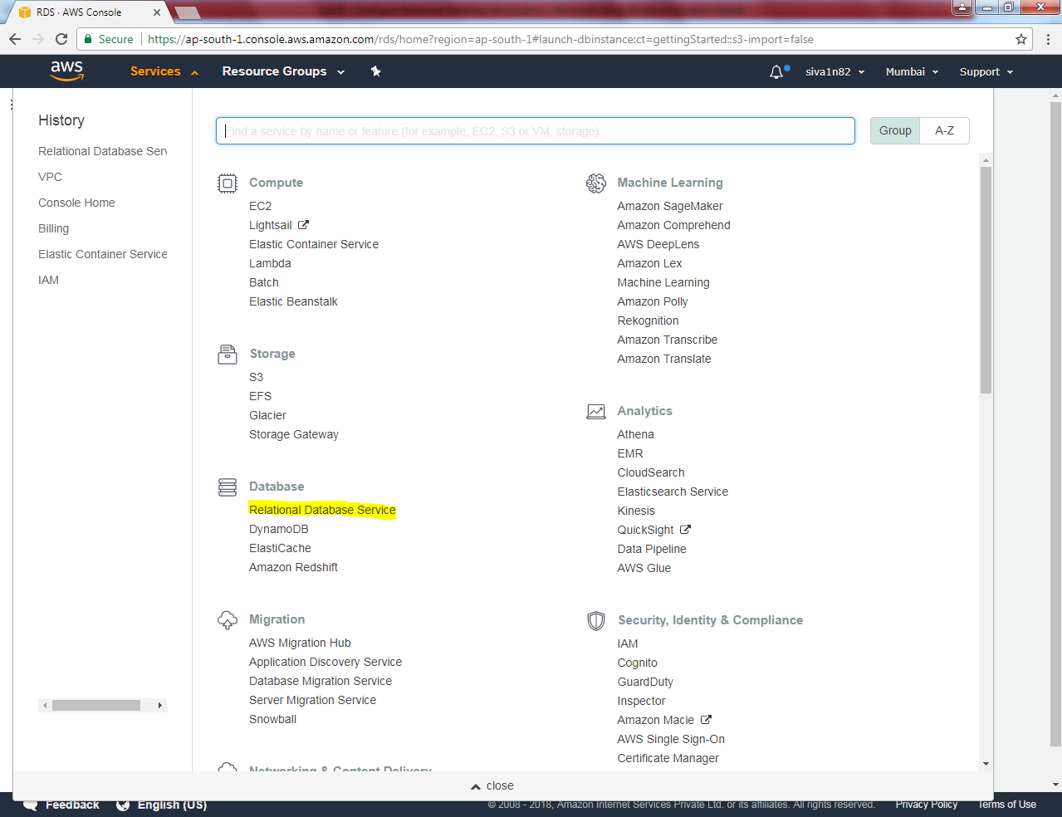

Click “Get started now”.

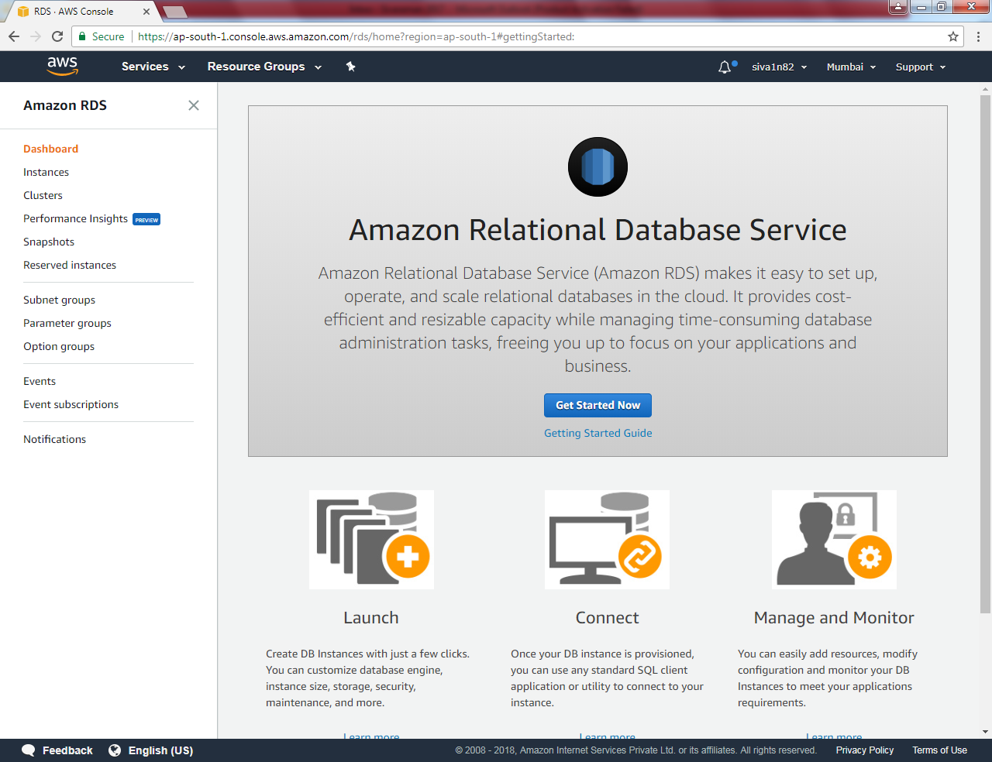

Click “MySql”.

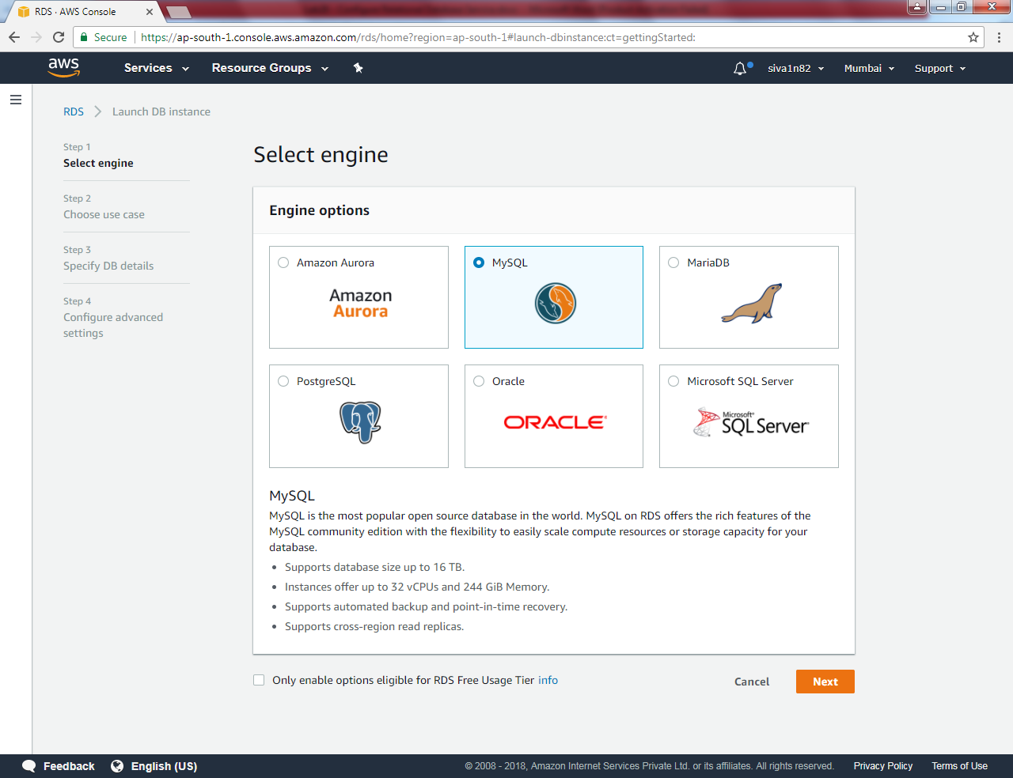

Select “ Production – MySQL”

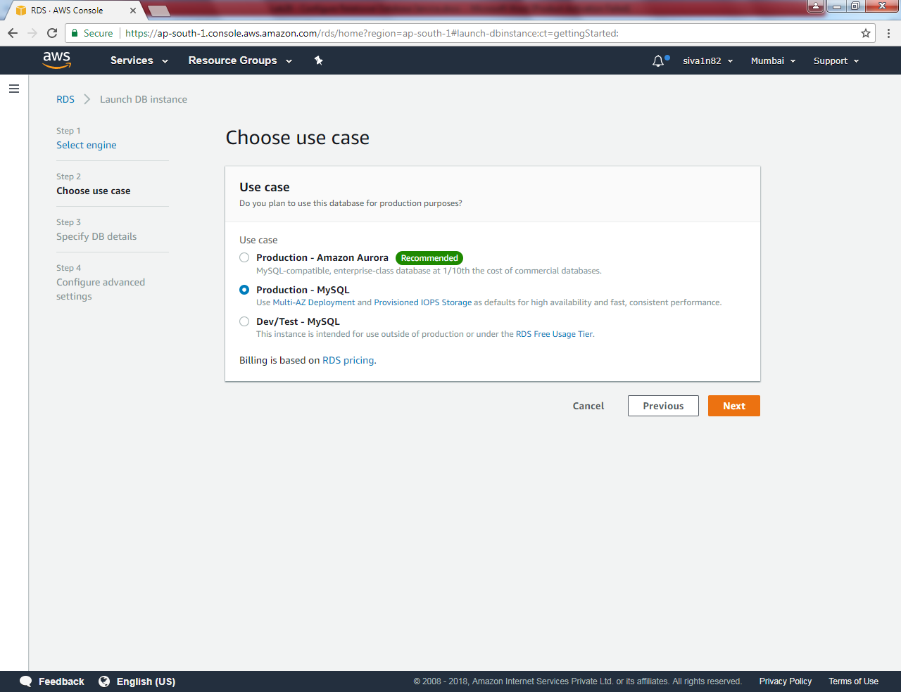

Click “Next”.

Leave mysql version by default.

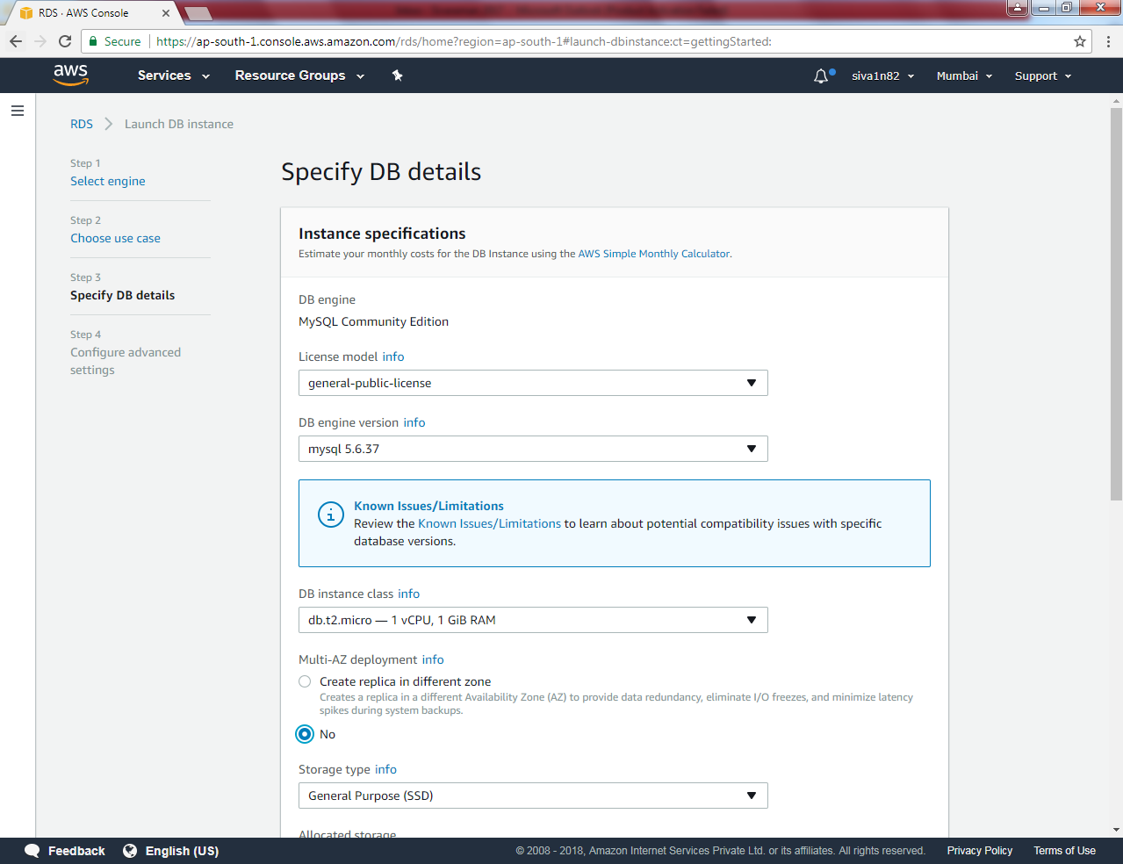

Select “t2.micro” otherwise charges will be applicable

Scroll down

Type DB instance name as sansbounddb

Master username: root

Master password:

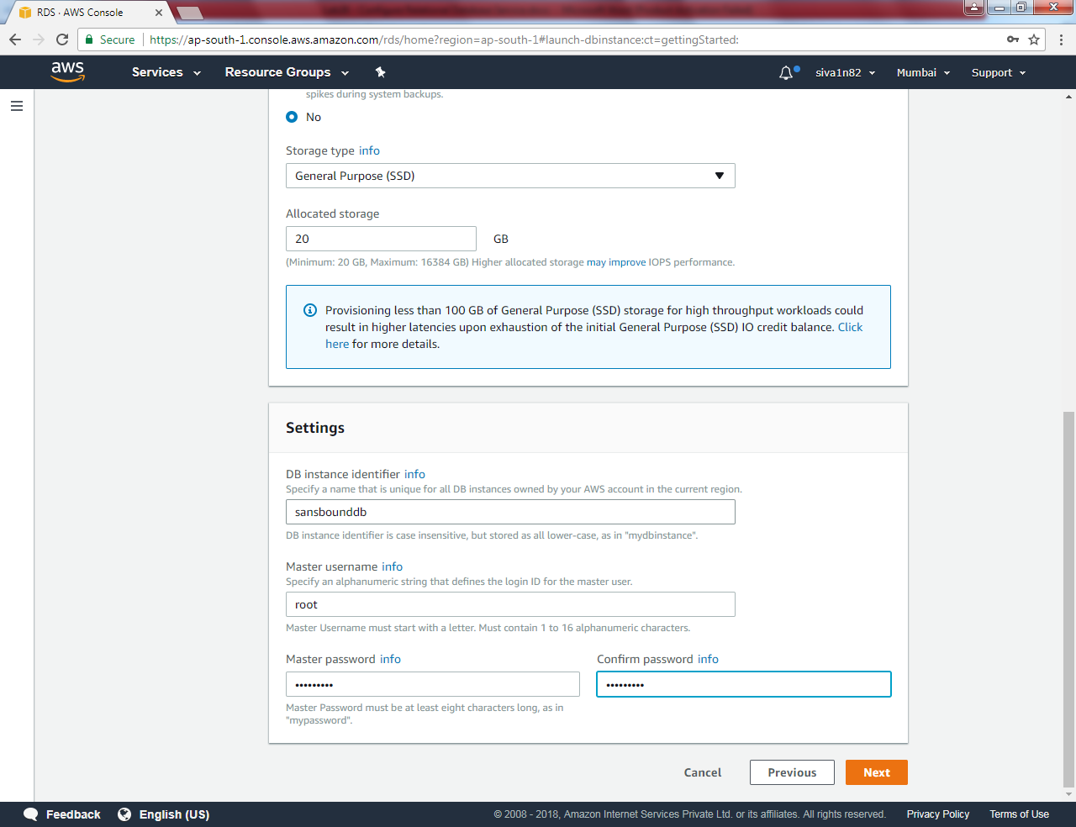

Click “Next”.

Select VPC as default VPC

Subnet as Default subnet

Public accessibility : Yes

Create a new security Group

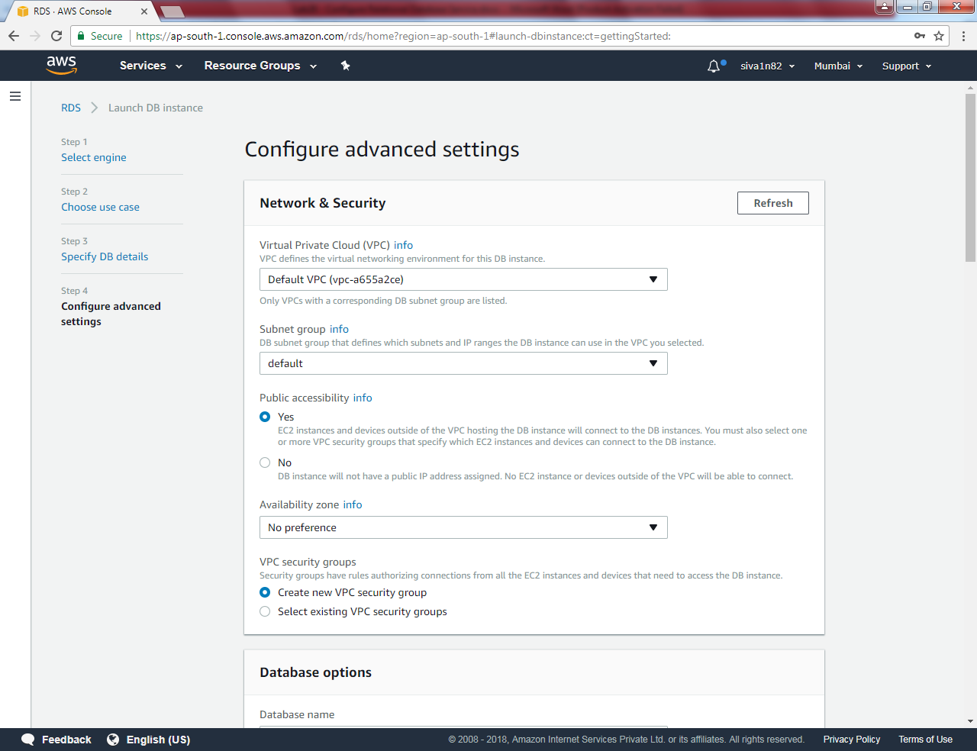

Scroll down

Database options

Dbname: Sansbounddb

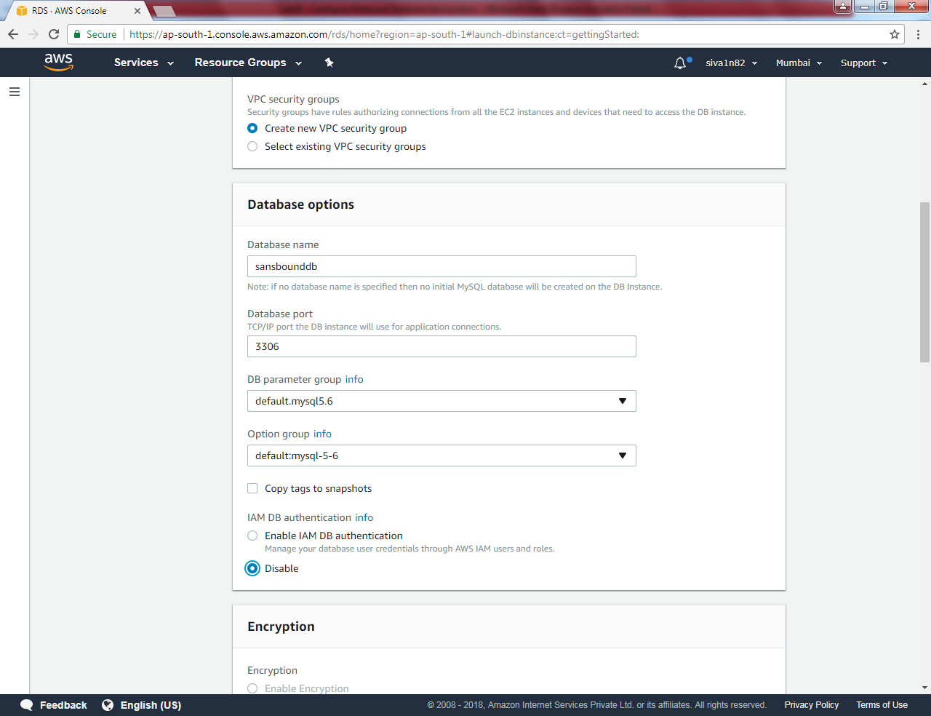

Scroll down

Backup 7 days

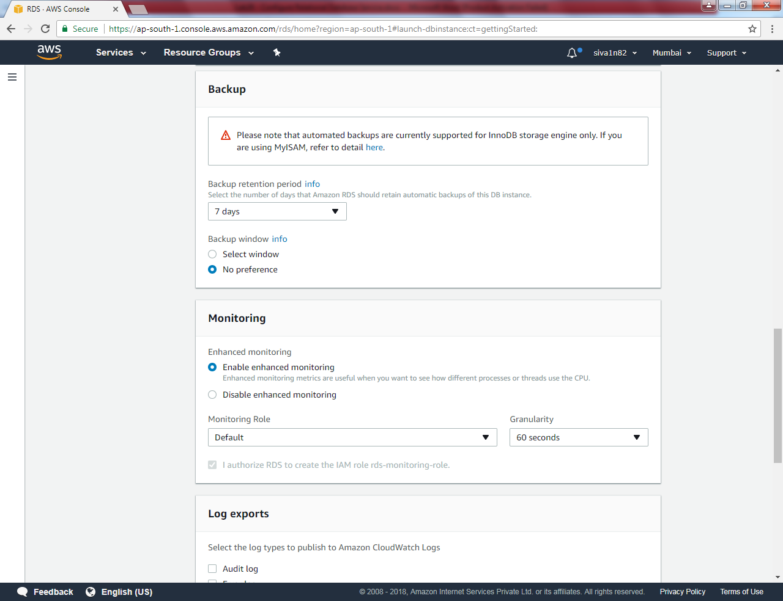

Scroll down.

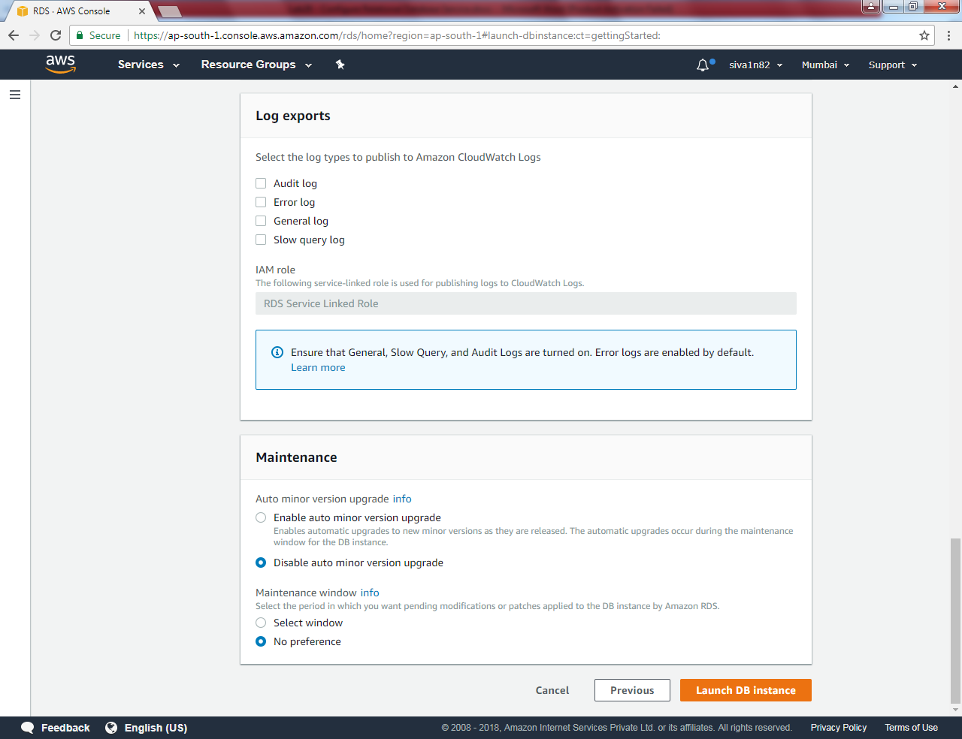

Click “Launch DB Instance”.

You have got a message that Your DB instance is being created.

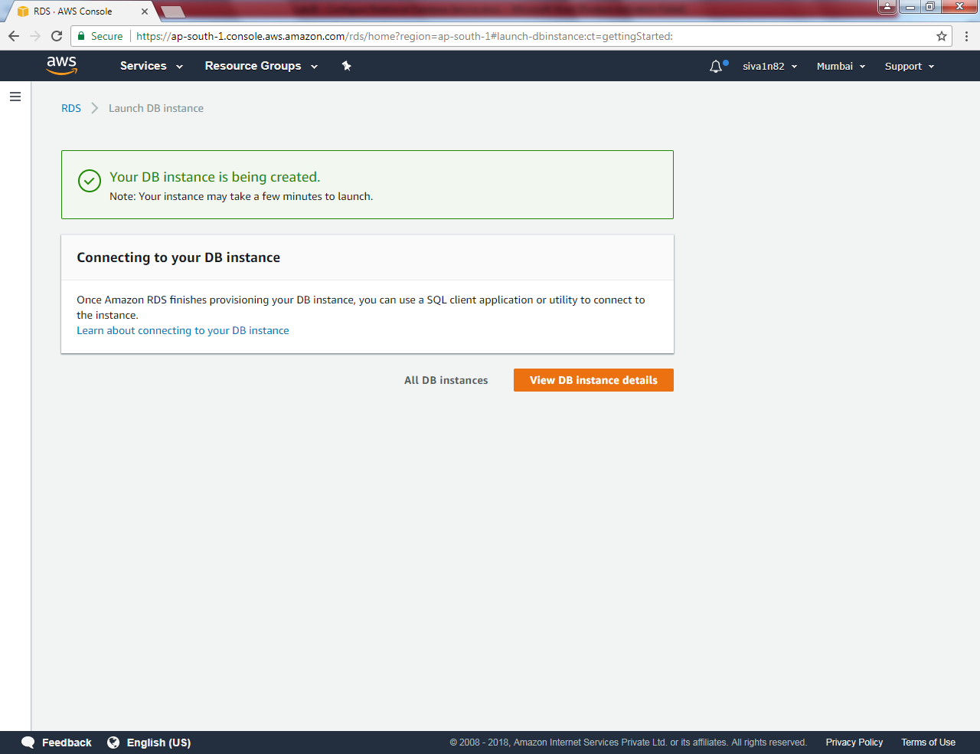

Click “View DB instance details”.

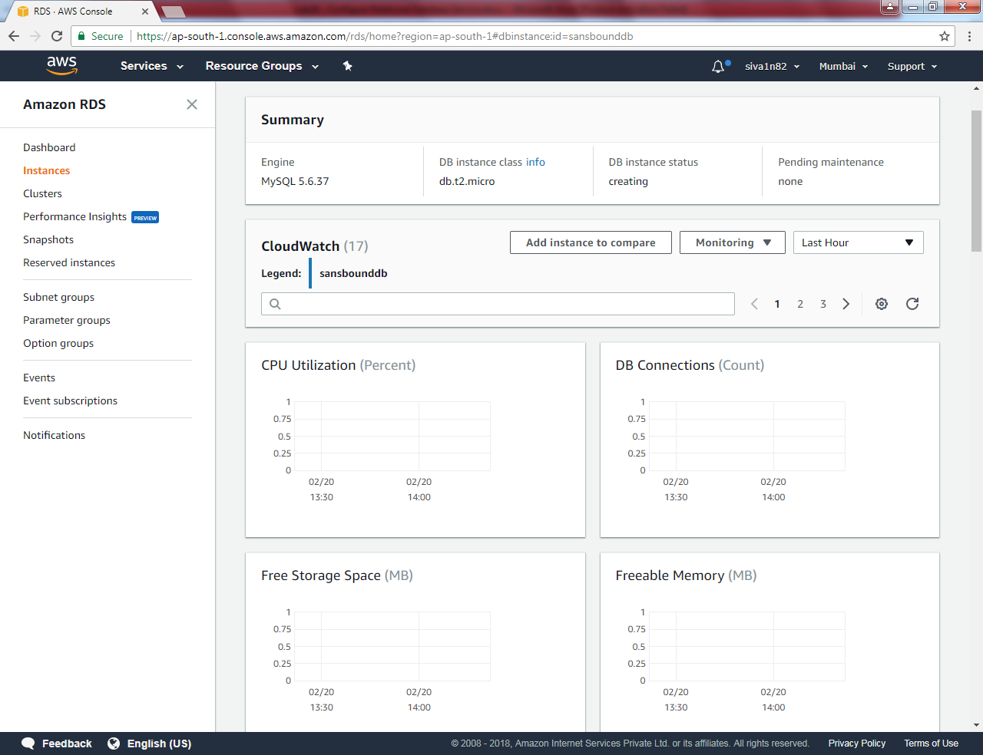

You can able to see that instance is getting created.

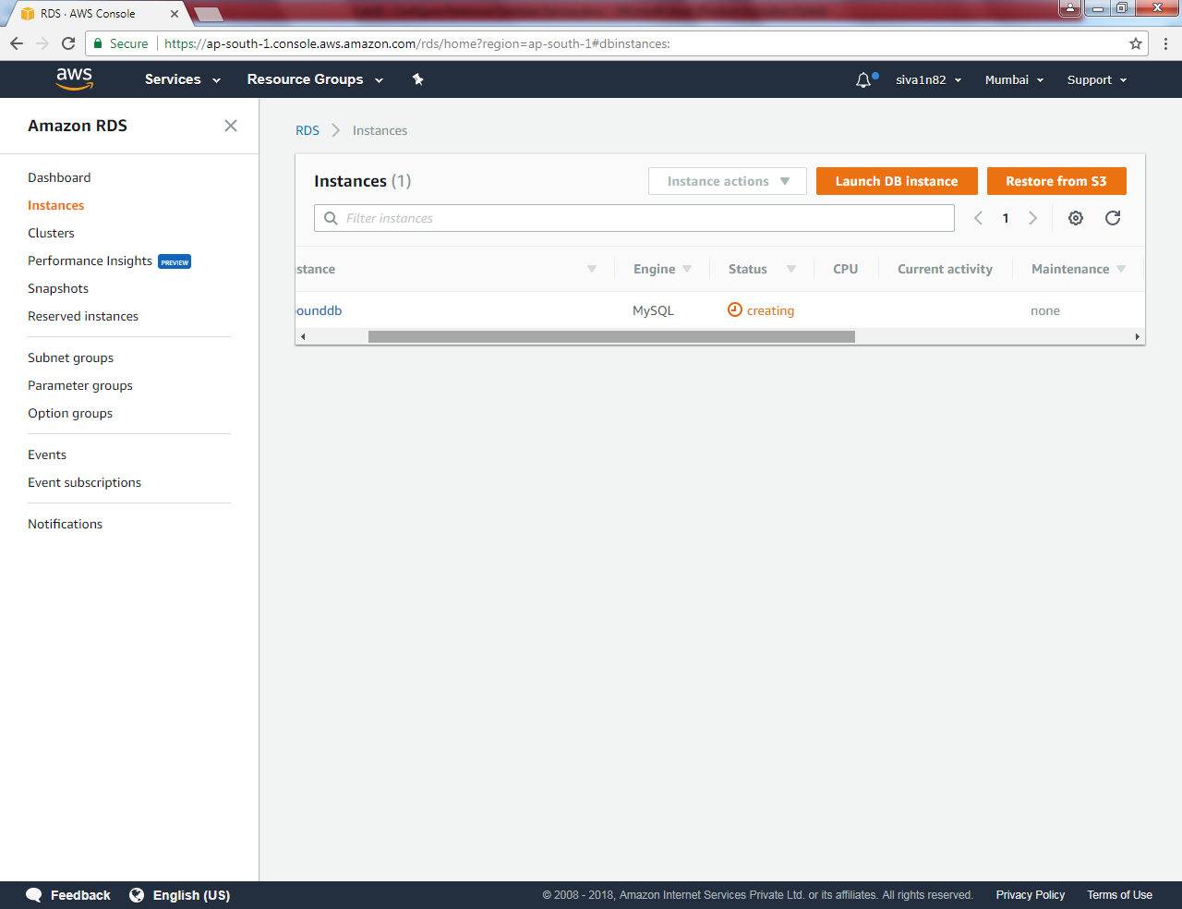

Now instance is taking backup.

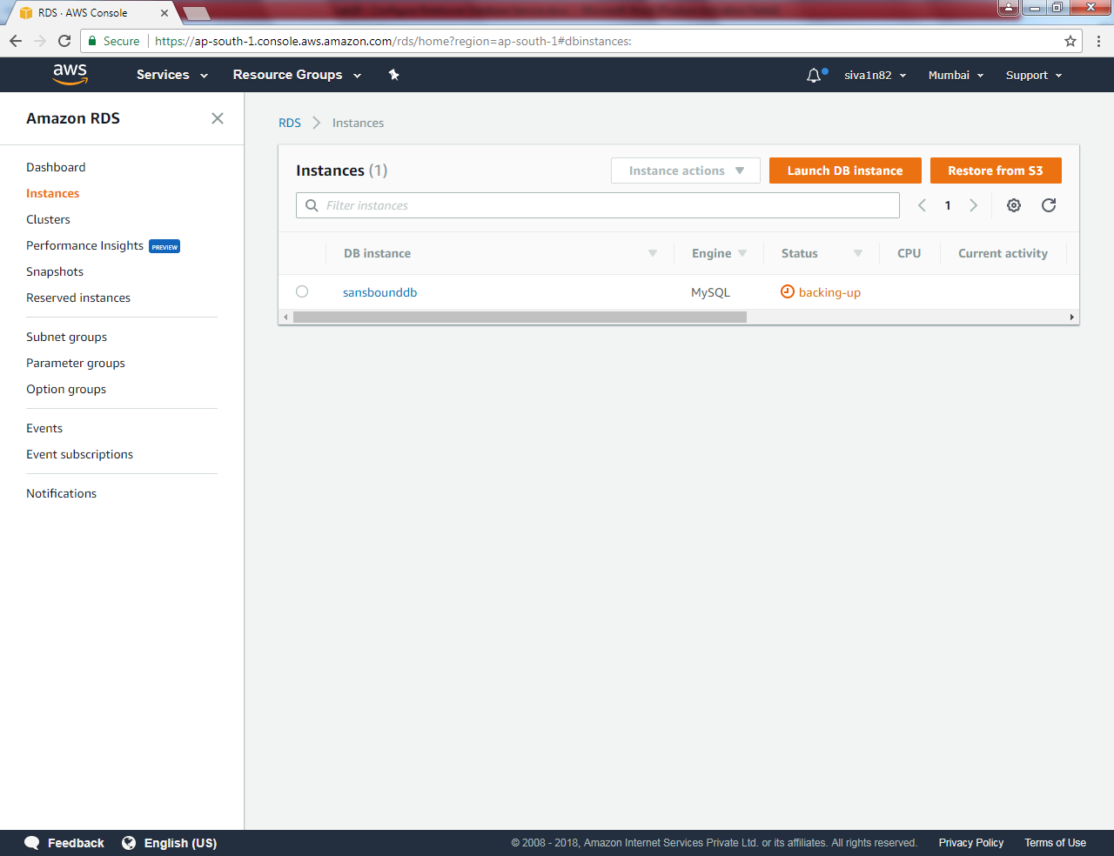

Now instance is available.

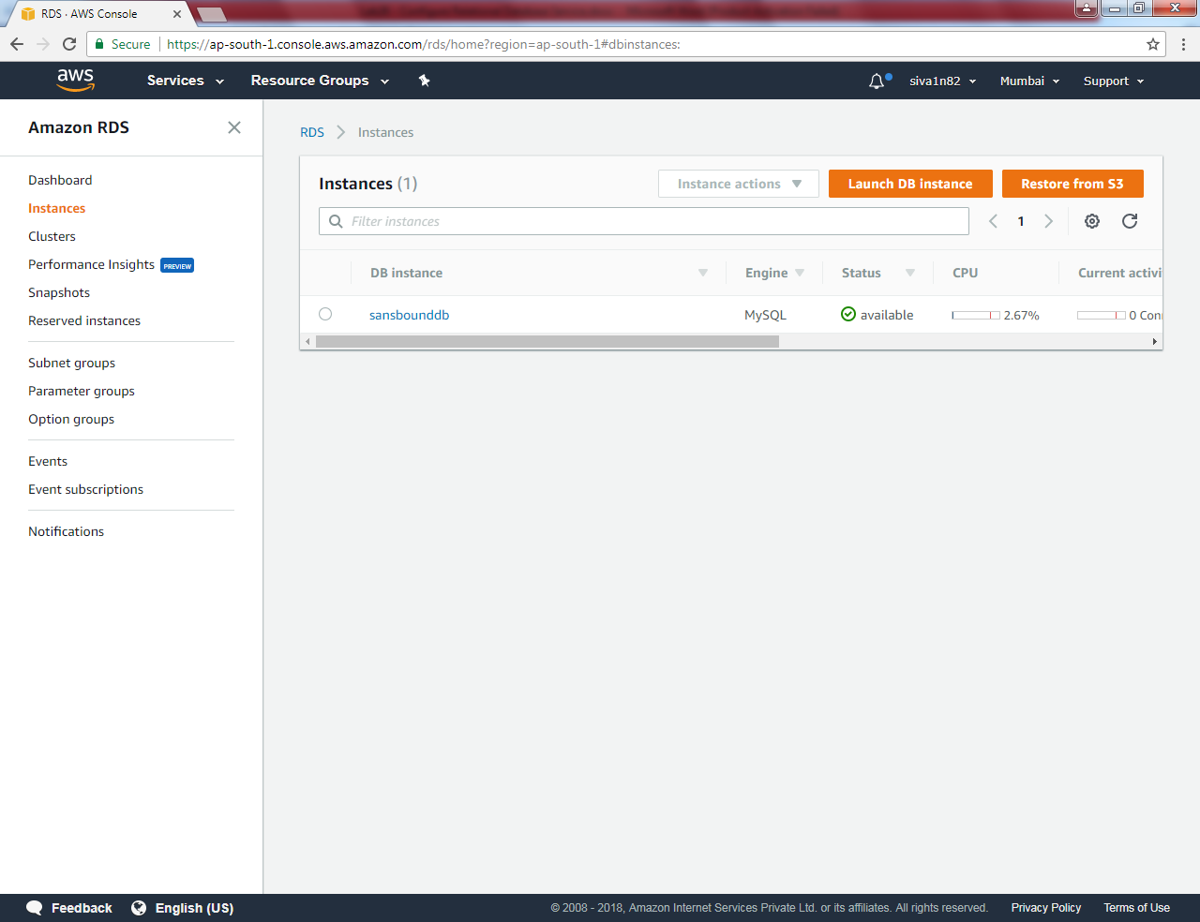

Please find the URL of Endpoint as below. Kindly use the endpoint URL in MY workbench and using port details to connect.

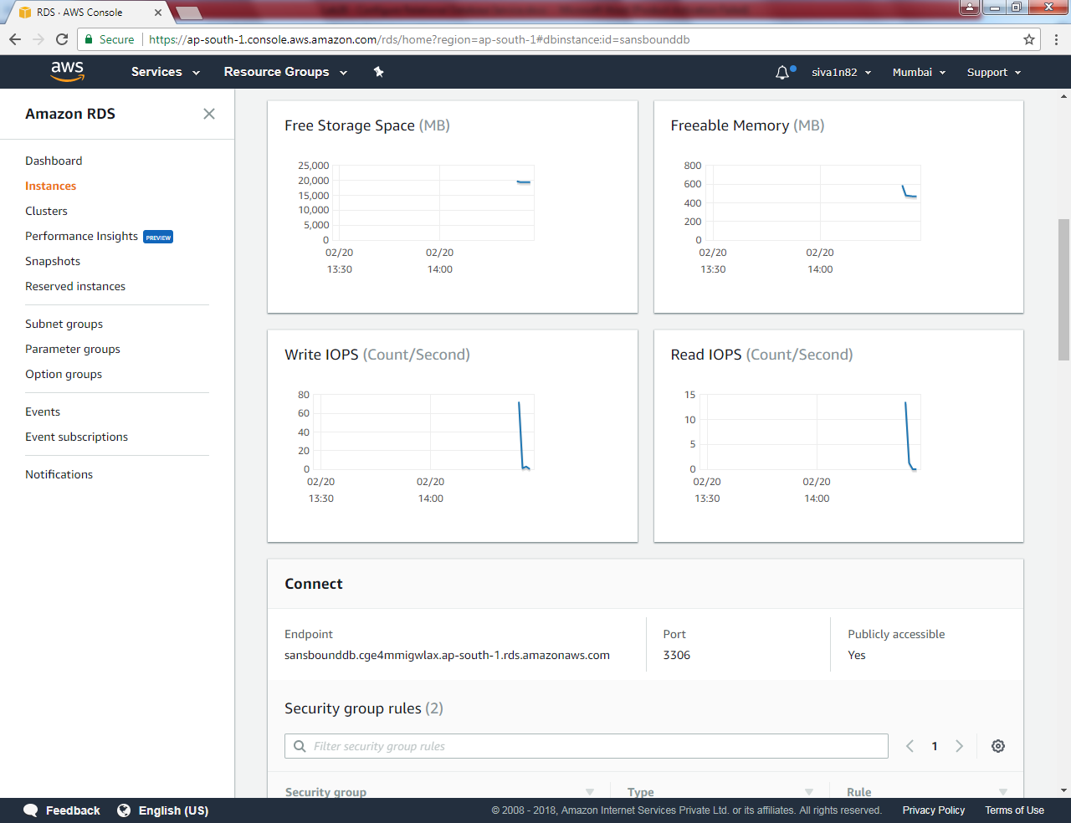

You can able to see the security group details as below.

